Suggestions to re-shape raw or broken data into a more machine-readable or machine friendly data.
- Perform a quick check that the PK column does indeed reflect unique IDs (no doubles, no nulls, no types other than integers). 
- Try to get some insights into the missing IDs and on a potential link between those IDs and other attributes.
- Title is a long string, try to fraction it and extract some other useful information that could potentially constitute a new column attribute. Perform a quick check of the minimum and maximum string lengths found before segmentation, and make sure there are no nulls. 
- Get authors on separate columns and try to transform them into numeric references for a more ML friendly input.
- Assess the risk of removing both columns isbn(13). What are their added value compared to book IDs?
- Enumerate all languages and transform into numeric input (vectorize).
- Deal with null values in number of reviews and number of written notes.
- Process publication date into integers (keep only year or keep also months?)
- Process publisher same as for authors.

- Getting data into data_frame template in Python (Jupyterlab environment) and deal with first issues:
- No conform data
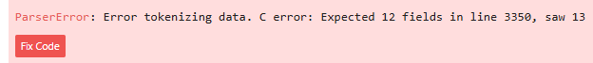
- Loaded the .csv in data frame using the pd.read_csv function with the attribute “warn” which highlighted 4 corrupted lines 3350, 4704, 5879 & 8981.
- Manually repaired the corrupted lines then loaded the new set of data again in the same variable “df” (data frame).
  - In line 3350, merged two author names Sam Bass Warner/Sam B. Warner Jr into cell “C”.
  - In line 4704, merged more authors and details about Turgon author, into cell “C”.
  - In line 5879, put together the author name and last name into unique cell “C”.
  - In line 8981, merged authors full name in cell “C”.
- Found 775 duplicated titles, found Chinese characters,

